Paper examining prevalence and perceived utility of mHealth tech among RIHA

Descriptive analysis

Brad Cannell

Updated: 2022-12-12

|  |  |  |
| --- | --- | --- |
| **Variable type** | **Variable** | **Survey item or notes if unclear from variable** |
| Predictors | Age |  |
|  | Gender |  |
|  | Hispanic Ethnicity |  |
|  | Race | What’s best way to do this? Dichotomize as AA vs other? Or Dummy code with AA vs non-White and AA vs White? Presumably AA should be referent condition. |
|  | Have GED or HS diploma |  |
|  | Employment status |  |
|  | Lifetime total time homeless (months) |  |
|  | Lifetime total time in jail or prison (years) |  |
|  | Current mental health treatment | “Currently receiving treatment for mental health problems” |
|  | General health |  |
|  | Have a cell phone |  |
|  | Data plan | “Does your phone service include a data plan?” |
| Outcome 1 | Prevalence | “Ever used smartphone app to manage one or more health-related issues” |
| Outcome 2 | Perceived utility | “Smartphone app can help you to change your actions or behavior” |

In the current study, we did not seek to test a specific hypothesis. Rather, we were interested in descriptively exploring the relationships between using a smartphone app to manage health-related uses and each of the following: sociodemographic background, lifetime homelessness, lifetime incarceration, physical and mental health, and access to a mobile phone and data plan. We similarly explored the relationships between the various participant characteristics listed above and the participant’s beliefs about whether a smartphone app can help them change their actions and behaviors.

We calculated descriptive point estimates (i.e., means and frequencies) and interval estimates (i.e., 95% confidence intervals) for each of the relationships listed above. Statistical analyses were conducted using R version 4.1.0 (R Core Team, 2021) in RStudio version 1.4.1717 (RStudio Team, 2021) with the following packages: tidyverse (Wickham et al., 2019), freqtables (Cannell, 2020), meantables (Cannell, 2020).

**Table 1**. Characteristics of participants who completed the Link2Care baseline assessments (n = n_baseline).

| **Characteristic** | **Statistics** |
| --- | --- |
| Age, mean (sd) | 39.8 (10.9) |
|  |  |
| Gender, n (%) |  |
| Male | 275 (84.9) |
| Female | 44 (13.6) |
| Other | 5 (1.5) |
|  |  |
| Race/Ethnicity, n (%) |  |
| White, non-Hispanic | 54 (16.7) |
| Black, non-Hispanic | 194 (59.9) |
| Hispanic, any race | 42 (13.0) |
| Other race, non-Hispanic | 34 (10.5) |
|  |  |
| High school grad or GED, n (%) |  |
| No | 101 (31.2) |
| Yes | 223 (68.8) |
|  |  |
| Employment status, n (%) |  |
| Employed | 27 (8.3) |
| Unemployed, looking for work | 176 (54.3) |
| Unemployed, not looking for work | 47 (14.5) |
| Unable to work or disabled | 59 (18.2) |
| Other | 15 (4.6) |
|  |  |
| Lifetime months homeless, median (IQR) | 30.0 (53.6) |
|  |  |
| Lifetime years in jail, median (IQR) | 3.5 (6.7) |
|  |  |
| General health, n (%) |  |
| Excellent | 57 (17.6) |
| Very Good | 70 (21.6) |
| Good | 103 (31.8) |
| Fair | 70 (21.6) |
| Poor | 24 (7.4) |
|  |  |
| N days out of past 30 physical health not good, mean (sd) | 7.2 (9.9) |
|  |  |
| N days out of past 30 mental health not good, mean (sd) | 11.7 (11.1) |
|  |  |
| Mental health treatment, n (%) |  |
| No | 136 (42.0) |
| Yes | 188 (58.0) |
|  |  |
| Have mobile phone, n (%) |  |
| No | 232 (71.6) |
| Yes | 92 (28.4) |
|  |  |
| Mobile phone bill payer, n (%) |  |
| Government | 10 (10.9) |
| Family or friend | 29 (31.5) |
| Someone else | 4 (4.3) |
| I pay for my cell phone service | 49 (53.3) |
|  |  |
| Talk minutes in mobile plan, n (%) |  |
| 0-200 | 3 (3.3) |
| 201-400 | 4 (4.3) |
| 401-600 | 1 (1.1) |
| Unlimited | 80 (87.0) |
| I use 'pay as you go' or prepaid phone | 4 (4.3) |
|  |  |
| Is mobile phone a smart phone, n (%) |  |
| No | 14 (15.2) |
| Yes - I have an android phone | 74 (80.4) |
| Yes - I have a Apple smartphone (iPhone) | 3 (3.3) |
| Yes - I have a Smartphone that is not Apple or Android based | 1 (1.1) |
|  |  |
| Have data plan, n (%)1 |  |
| No | 4 (5.1) |
| Yes, but my data plan is limited | 22 (28.2) |
| Yes, my plan includes unlimited data | 52 (66.7) |
|  |  |
| N times mobile number has changed, n (%) |  |
| 0 | 66 (24.4) |
| 1 | 62 (22.9) |
| 2 | 65 (24.0) |
| 3 | 29 (10.7) |
| 4 | 18 (6.6) |
| 5 or more | 31 (11.4) |
|  |  |
| Types of media used, n (%)2 |  |
| Email | 250 (77.2) |
| Facebook | 227 (70.1) |
| Google Plus | 127 (39.2) |
| Twitter | 29 (9.0) |
| Blogs | 9 (2.8) |
| Instagram | 86 (26.5) |
| Snapchat | 42 (13.0) |
| LinkedIn | 25 (7.7) |
| None | 28 (8.6) |
|  |  |
| Frequency of internet access, n (%) |  |
| Never | 25 (7.7) |
| About once a month | 12 (3.7) |
| About once per week | 16 (4.9) |
| 2-3 times per week | 31 (9.6) |
| 4 to 6 times per week | 18 (5.6) |
| About once per day | 31 (9.6) |
| About twice per day | 42 (13.0) |
| Every few hours or more | 149 (46.0) |
|  |  |
| Frequency of Facebook use, n (%) |  |
| Never | 22 (10.0) |
| About once a month | 19 (8.6) |
| About once per week | 13 (5.9) |
| 2-3 times per week | 29 (13.2) |
| 4 to 6 times per week | 14 (6.4) |
| About once per day | 32 (14.5) |
| About twice per day | 31 (14.1) |
| Every few hours or more | 60 (27.3) |
|  |  |
| Believe smartphone app can help change actions or behaviors, n (%) |  |
| No | 55 (17.2) |
| Yes | 265 (82.8) |
|  |  |
| used smartphone app to manage health-related issues, n (%) |  |
| No | 242 (74.9) |
| Yes | 81 (25.1) |
|  |  |
| Type of issue managed with smartphone app, n (%)3 |  |
| Food or calorie tracking | 41 (50.0) |
| Medication reminders | 40 (48.8) |
| Mood manager | 20 (24.4) |
| Physical activity | 42 (51.2) |
| Sleep tracker | 25 (30.5) |
| Smoking Cessation | 14 (17.1) |
| Stress reduction | 31 (37.8) |
| Weight loss tracking | 23 (28.0) |
| Other | 19 (23.2) |
|  |  |
| Number of issues managed with smartphone app, n (%)4 |  |
| 1 | 11 (13.6) |
| 2 | 28 (34.6) |
| 3 | 16 (19.8) |
| 4 | 11 (13.6) |
| 5 | 4 (4.9) |
| 6 | 5 (6.2) |
| 7 | 3 (3.7) |
| 8 | 3 (3.7) |
| 9 | 0 (0.0) |
|  |  |
| Number of issues managed with smartphone app, n (%) |  |
| 0 | 242 (74.9) |
| 1 | 11 (3.4) |
| 2 | 28 (8.7) |
| 3 | 16 (5.0) |
| 4 | 11 (3.4) |
| 5 | 4 (1.2) |
| 6 | 5 (1.5) |
| 7 | 3 (0.9) |
| 8 | 3 (0.9) |
| 9 | 0 (0.0) |
| 1Have data plan was only asked of participants who reported having a mobile phone. | |
| 2Percentages sum to >100% because participants could select more than one response option. | |
| 3Percentages sum to >100% because participants could select more than one response option. | |
| 4Among participants who reported managing any issues with smartphone app. | |

# 2022-12-12 R&R for Journal of Technology in Behavioral Science

**Figure X.** Percentage of participants who reported using a smartphone app to manage each of the following types of issues.

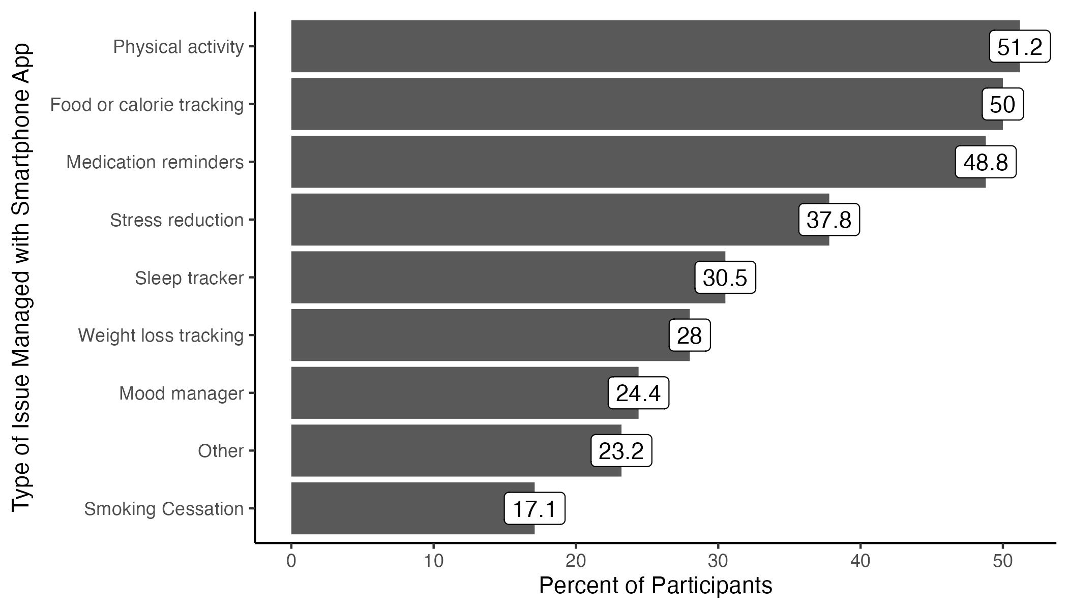

1. Only asked of participants who reported managing *any* issues with a smartphone app (n = 81).

2. Percentages sum to >100% because participants could select more than one response option.

**Figure X.** The total number of issues managed using a smartphone app by participants – among the 9 options supplied (see Figure X).

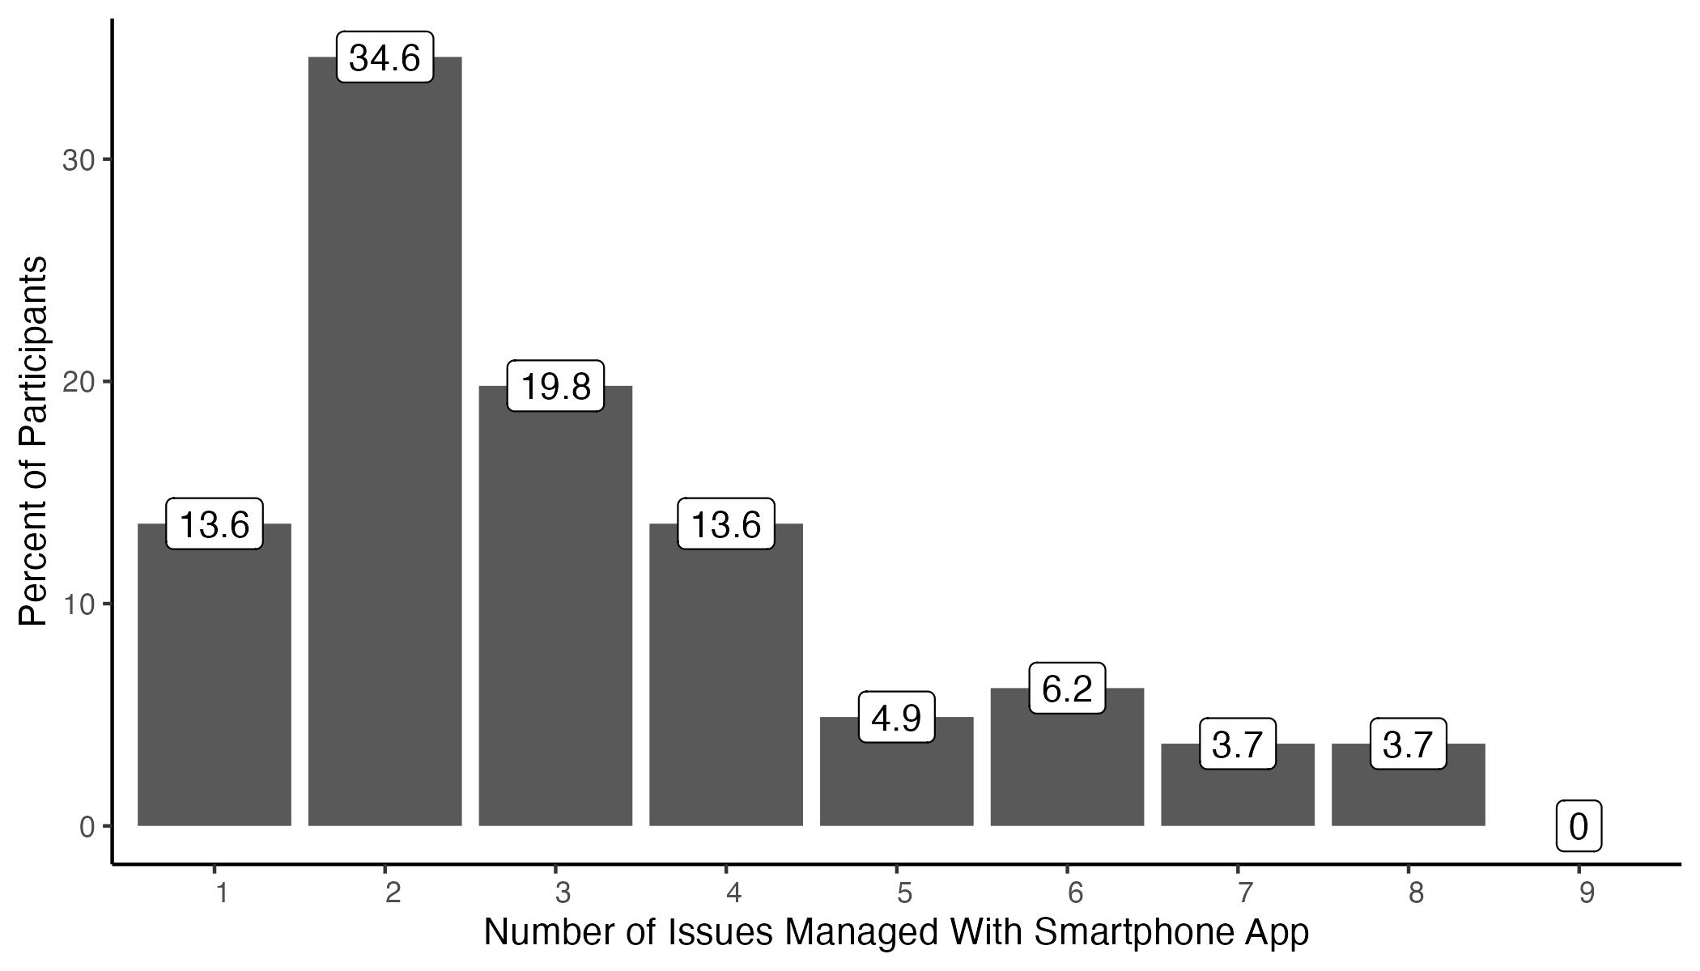

1. Only asked of participants who reported managing *any* issues with a smartphone app (n = 81).

**Figure X.** The total number of issues managed using a smartphone app by participants – among the 9 options supplied (see Figure X).

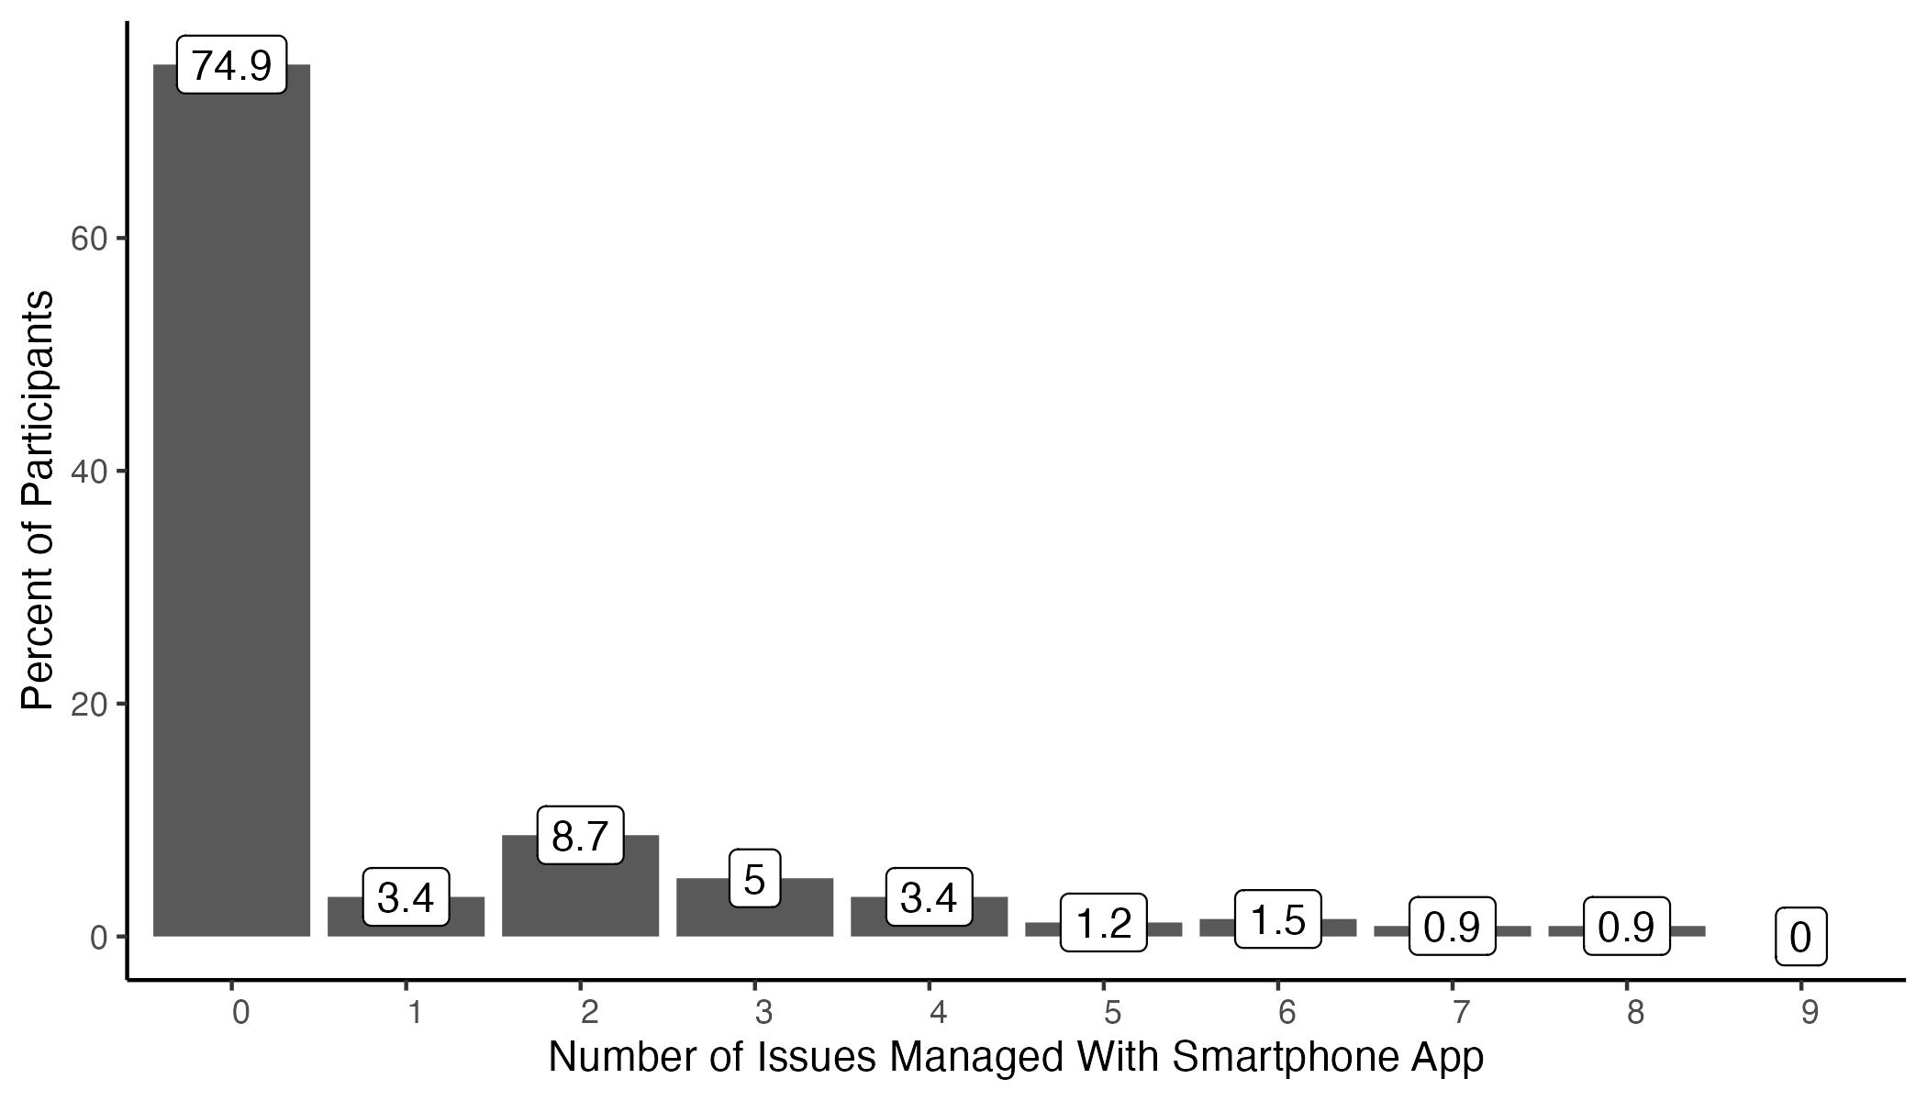

## Crosstabs

The comments on the R&R indicated the need for us to create a few more crosstabs. I’ve tried my best to create what I think was requested below. These are basically raw output from R because I wanted to get them to you as soon as possible. I can clean them up later if you would like me to.

**Table X.** Access to internet by phone ownership

| row_var | row_cat | col_var | col_cat | n | n_row | percent_row |
| --- | --- | --- | --- | --- | --- | --- |
| mobile_have_f | No | access_internet_dichot_f | Yes | 208 | 232 | 89.65517 |
| mobile_have_f | Yes | access_internet_dichot_f | Yes | 91 | 92 | 98.91304 |

**Table X.** Any social media use by phone ownership

| row_var | row_cat | col_var | col_cat | n | n_row | percent_row |
| --- | --- | --- | --- | --- | --- | --- |
| mobile_have_f | No | sm_use_any_f | Yes | 208 | 232 | 89.65517 |
| mobile_have_f | Yes | sm_use_any_f | Yes | 88 | 92 | 95.65217 |

**Table 2**. Characteristics of participants who completed the Link2Care baseline assessments (n = 324) by phone ownership.

| **Characteristic** | **No Mobile Phone (n=232)** | **Mobile Phone (n=92)** |
| --- | --- | --- |
| Age, mean (sd) | 39.9 (11.2) | 39.3 (10.0) |
|  |  |  |
| Gender, n (%) |  |  |
| Male | 198 (85.3) | 77 (83.7) |
| Female | 29 (12.5) | 15 (16.3) |
| Other | 5 (2.2) | 0 (0.0) |
|  |  |  |
| Race/Ethnicity, n (%) |  |  |
| White, non-Hispanic | 44 (19.0) | 10 (10.9) |
| Black, non-Hispanic | 140 (60.3) | 54 (58.7) |
| Hispanic, any race | 25 (10.8) | 17 (18.5) |
| Other race, non-Hispanic | 23 (9.9) | 11 (12.0) |
|  |  |  |
| High school grad or GED, n (%) |  |  |
| No | 77 (33.2) | 24 (26.1) |
| Yes | 155 (66.8) | 68 (73.9) |
|  |  |  |
| Employment status, n (%) |  |  |
| Employed | 14 (6.0) | 13 (14.1) |
| Unemployed, looking for work | 135 (58.2) | 41 (44.6) |
| Unemployed, not looking for work | 34 (14.7) | 13 (14.1) |
| Unable to work or disabled | 40 (17.2) | 19 (20.7) |
| Other | 9 (3.9) | 6 (6.5) |
|  |  |  |
| Lifetime months homeless, median (IQR) | 29.5 (53.2) | 31.5 (53.5) |
|  |  |  |
| Lifetime years in jail, median (IQR) | 4.0 (7.0) | 3.0 (5.4) |
|  |  |  |
| General health, n (%) |  |  |
| Excellent | 39 (16.8) | 18 (19.6) |
| Very Good | 52 (22.4) | 18 (19.6) |
| Good | 69 (29.7) | 34 (37.0) |
| Fair | 54 (23.3) | 16 (17.4) |
| Poor | 18 (7.8) | 6 (6.5) |
|  |  |  |
| N days out of past 30 physical health not good, mean (sd) | 7.5 (9.9) | 6.4 (10.0) |
|  |  |  |
| N days out of past 30 mental health not good, mean (sd) | 12.0 (11.2) | 11.1 (10.9) |
|  |  |  |
| Mental health treatment, n (%) |  |  |
| No | 97 (41.8) | 39 (42.4) |
| Yes | 135 (58.2) | 53 (57.6) |
|  |  |  |
| Mobile phone bill payer, n (%) |  |  |
| Government | 0 (NaN) | 10 (10.9) |
| Family or friend | 0 (NaN) | 29 (31.5) |
| Someone else | 0 (NaN) | 4 (4.3) |
| I pay for my cell phone service | 0 (NaN) | 49 (53.3) |
|  |  |  |
| Talk minutes in mobile plan, n (%) |  |  |
| 0-200 | 0 (NaN) | 3 (3.3) |
| 201-400 | 0 (NaN) | 4 (4.3) |
| 401-600 | 0 (NaN) | 1 (1.1) |
| Unlimited | 0 (NaN) | 80 (87.0) |
| I use 'pay as you go' or prepaid phone | 0 (NaN) | 4 (4.3) |
|  |  |  |
| Is mobile phone a smart phone, n (%) |  |  |
| No | 0 (NaN) | 14 (15.2) |
| Yes - I have an android phone | 0 (NaN) | 74 (80.4) |
| Yes - I have a Apple smartphone (iPhone) | 0 (NaN) | 3 (3.3) |
| Yes - I have a Smartphone that is not Apple or Android based | 0 (NaN) | 1 (1.1) |
|  |  |  |
| Have data plan, n (%)1 |  |  |
| No | 0 (NaN) | 4 (5.1) |
| Yes, but my data plan is limited | 0 (NaN) | 22 (28.2) |
| Yes, my plan includes unlimited data | 0 (NaN) | 52 (66.7) |
|  |  |  |
| N times mobile number has changed, n (%) |  |  |
| 0 | 39 (21.8) | 27 (29.3) |
| 1 | 47 (26.3) | 15 (16.3) |
| 2 | 45 (25.1) | 20 (21.7) |
| 3 | 16 (8.9) | 13 (14.1) |
| 4 | 11 (6.1) | 7 (7.6) |
| 5 or more | 21 (11.7) | 10 (10.9) |
| I have not had a phone in the past year | 0 (0.0) | 0 (0.0) |
|  |  |  |
| Types of media used, n (%)2 |  |  |
| Email | 171 (73.7) | 79 (85.9) |
| Facebook | 159 (68.5) | 68 (73.9) |
| Google Plus | 97 (41.8) | 30 (32.6) |
| Twitter | 21 (9.1) | 8 (8.7) |
| Blogs | 7 (3.0) | 2 (2.2) |
| Instagram | 55 (23.7) | 31 (33.7) |
| Snapchat | 31 (13.4) | 11 (12.0) |
| LinkedIn | 16 (6.9) | 9 (9.8) |
| None | 24 (10.3) | 4 (4.3) |
|  |  |  |
| Frequency of internet access, n (%) |  |  |
| Never | 24 (10.3) | 1 (1.1) |
| About once a month | 10 (4.3) | 2 (2.2) |
| About once per week | 15 (6.5) | 1 (1.1) |
| 2-3 times per week | 24 (10.3) | 7 (7.6) |
| 4 to 6 times per week | 14 (6.0) | 4 (4.3) |
| About once per day | 25 (10.8) | 6 (6.5) |
| About twice per day | 26 (11.2) | 16 (17.4) |
| Every few hours or more | 94 (40.5) | 55 (59.8) |
|  |  |  |
| Frequency of Facebook use, n (%) |  |  |
| Never | 20 (13.2) | 2 (2.9) |
| About once a month | 12 (7.9) | 7 (10.1) |
| About once per week | 11 (7.3) | 2 (2.9) |
| 2-3 times per week | 17 (11.3) | 12 (17.4) |
| 4 to 6 times per week | 10 (6.6) | 4 (5.8) |
| About once per day | 20 (13.2) | 12 (17.4) |
| About twice per day | 22 (14.6) | 9 (13.0) |
| Every few hours or more | 39 (25.8) | 21 (30.4) |
|  |  |  |
| Believe smartphone app can help change actions or behaviors, n (%) |  |  |
| No | 31 (13.5) | 24 (26.4) |
| Yes | 198 (86.5) | 67 (73.6) |
|  |  |  |
| used smartphone app to manage health-related issues, n (%) |  |  |
| No | 172 (74.5) | 70 (76.1) |
| Yes | 59 (25.5) | 22 (23.9) |
|  |  |  |
| Type of issue managed with smartphone app, n (%)3 |  |  |
| Food or calorie tracking | 30 (50.0) | 11 (50.0) |
| Medication reminders | 28 (46.7) | 12 (54.5) |
| Mood manager | 15 (25.0) | 5 (22.7) |
| Physical activity | 33 (55.0) | 9 (40.9) |
| Sleep tracker | 17 (28.3) | 8 (36.4) |
| Smoking Cessation | 9 (15.0) | 5 (22.7) |
| Stress reduction | 19 (31.7) | 12 (54.5) |
| Weight loss tracking | 16 (26.7) | 7 (31.8) |
| Other | 13 (21.7) | 6 (27.3) |
|  |  |  |
| Number of issues managed with smartphone app, n (%)4 |  |  |
| 1 | 9 (15.3) | 2 (9.1) |
| 2 | 21 (35.6) | 7 (31.8) |
| 3 | 9 (15.3) | 7 (31.8) |
| 4 | 9 (15.3) | 2 (9.1) |
| 5 | 4 (6.8) | 0 (0.0) |
| 6 | 4 (6.8) | 1 (4.5) |
| 7 | 3 (5.1) | 0 (0.0) |
| 8 | 0 (0.0) | 3 (13.6) |
| 9 | 0 (0.0) | 0 (0.0) |
|  |  |  |
| Number of issues managed with smartphone app, n (%) |  |  |
| 0 | 172 (74.5) | 70 (76.1) |
| 1 | 9 (3.9) | 2 (2.2) |
| 2 | 21 (9.1) | 7 (7.6) |
| 3 | 9 (3.9) | 7 (7.6) |
| 4 | 9 (3.9) | 2 (2.2) |
| 5 | 4 (1.7) | 0 (0.0) |
| 6 | 4 (1.7) | 1 (1.1) |
| 7 | 3 (1.3) | 0 (0.0) |
| 8 | 0 (0.0) | 3 (3.3) |
| 9 | 0 (0.0) | 0 (0.0) |
| 1Have data plan was only asked of participants who reported having a mobile phone. | | |
| 2Percentages sum to >100% because participants could select more than one response option. | | |
| 3Percentages sum to >100% because participants could select more than one response option. | | |
| 4Among participants who reported managing any issues with smartphone app. | | |

References:

R Core Team (2021). R: A language and environment for statistical computing. R Foundation for Statistical Computing, Vienna, Austria. <https://www.R-project.org/>.

RStudio Team (2021). RStudio: Integrated Development Environment for R. RStudio, PBC, Boston, MA. <http://www.rstudio.com/>.

Brad Cannell (2020). freqtables: Make Quick Descriptive Tables for Categorical Variables. R package version 0.1.0. <https://CRAN.R-project.org/package=freqtables>.

Brad Cannell (2020). meantables: Make Quick Descriptive Tables for Continuous Variables. R package version 0.1.0. <https://CRAN.R-project.org/package=meantables>.